Sherwood House Patients Participation Group Newsletter
Winter 2016/17

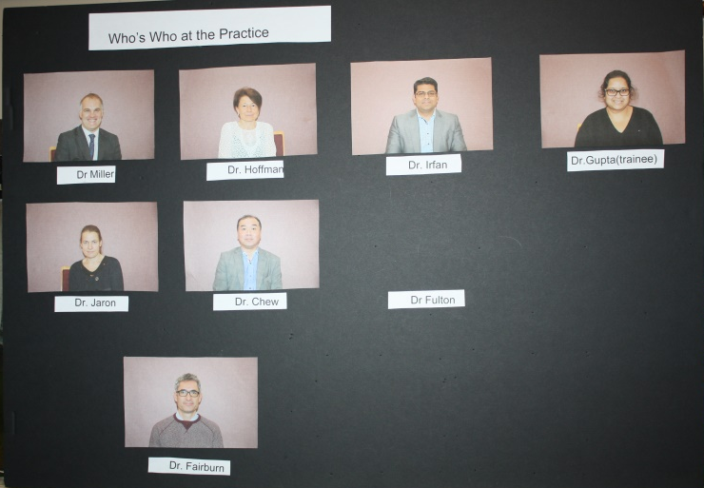

Sherwood House practice has agreed to display a Who’s Who Board in the practice foyer which has been developed by the Patients Participation Group. The idea was suggested by a patient in the survey undertaken by the Patients’ Participation Group last year.
The idea was supported by the Patients’ group because nearly a thousand new patients have joined the practice during this year. In addition, with Dr. Kay’s retirement earlier in the year, some patients have been allocated to a new GP.
The Board will be displayed at reception in order that patients can see which Doctor is which. It will also enable new patients to choose more easily if they want to see a female GP. The Board will also highlight the new trainees who are working at the practice and who will be seeing patients. Details of the new trainees are set out in the column to the right.
Practice Staff Changes
During the year three new trainees have joined the practice and are starting to see patients. A little bit of information about each is set out below with a picture.

Dr Gupta
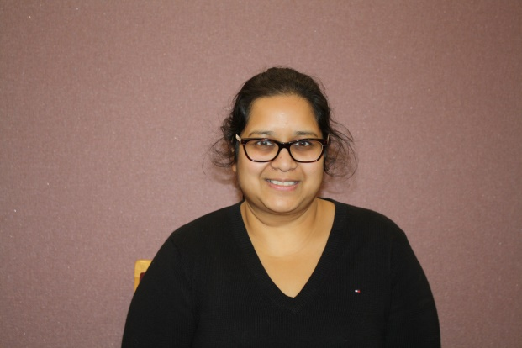

Staff Photo Board for the Practice

I am currently in my final year of GP training. I studied at the University of Birmingham and continued with my training within the West Midlands. Outside of medicine I enjoy travelling. It’s been a pleasure to work at Sherwood House and I look forward to meeting new patients over the coming months.

Dr Mahmoud Abu-Amara

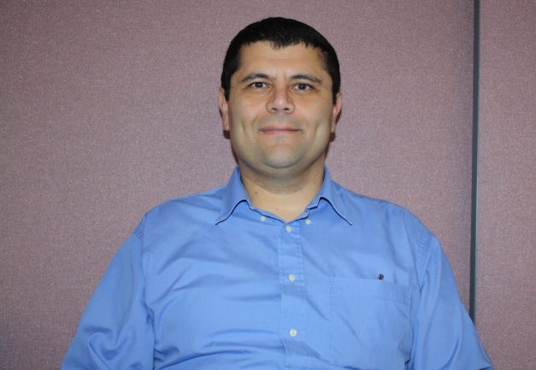

I am currently in the final year of GP training. Prior to moving into general practice I worked in surgery, liver disease and medical research. Sherwood House Medical Practice has a wide and varied patient population and it's been a pleasure working at the practice. I look forward to completing my year at the practice and to meeting more of the patients.

Dr. Wongso

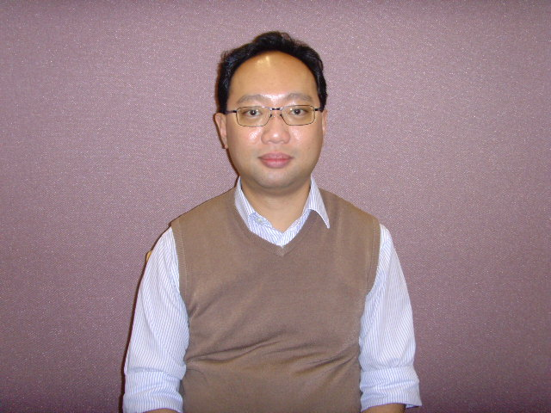

I am a final year GP registrar and have been with the practice since September 2016

Changes to Pharmacy Services

At the last PPG/Practice meeting we heard details of the Government’s 5 year plan for Pharmacy Services from Pete Szczepanski, Senior Clinical Prescribing Lead Pharmacist.

Under this plan, funding for pharmacy services will be reduced by between 15% and 17% and it is expected that up to a quarter of the current 12,000 pharmacies will close. Unfortunately there is no clear rationale based on need for the way this will happen and it will be more likely that a pharmacy will close when a pharmacist retires. Because of this it may be that some areas will lose a number of pharmacies and others may lose none. Some pharmacies are displaying petitions for patients to sign in order to let the government know there is concern about these plans.

In addition to closures, pharmacies are expected to do more to help treat patients who might otherwise go to the GP or primary care walk in centre. One such scheme, called Pharmacy First will enable patients to access the pharmacy for common ailments such as diarrhoea, head-lice, coughs and colds. Certain prescription only medication would be available as part of the scheme.

Pete also highlighted the new Electronic Transfer of Prescriptions whereby the GP sends the prescription electronically, direct to the patients’ choice of pharmacy. The pharmacy then dispenses it, ready for the patient to pick up. He also talked about discussions to standardise medication packs to 56 to make it easier for patients.

Survey on Nursing Care

At the patient participation group we try to look at results for the practice in National Surveys to ensure that the practice is performing well compared with others. When we looked at the results of the National Patient Survey undertaken by MORI the results for one area, nursing, were lower than we had expected. In order to find out whether this was just a one off we decided to repeat the survey locally. The questions in the survey are designed to find out about the last time patients saw a nurse from the surgery and how good the nurse was at the following areas:

- Giving enough time
- Listening to patients
- Explaining tests and treatments
- Involving patients in decisions about care
- Treating patients with care and concern

Overall the survey is trying to assess whether the patients have confidence and trust in the nurse they saw. The patient group got some patients to fill in the survey at the recent flu clinics and the surgery are now giving out the questionnaire to patients visiting the nurse in the run up to Xmas. Please fill it in if you are offered one. The results will be in the next Newsletter.

The Patients Group and the Practice would like to wish all patients a Happy Healthy 2017 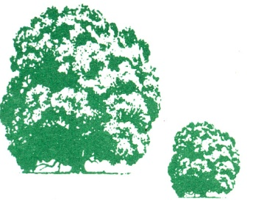
-

Happy Healthy 2017

