Sherwood House Patients Participation Group Newsletter
Summer 2017

Carers
Who are Carers?
Carers provide unpaid care by looking after an ill, older or disabled family member friend or partner.
It could be a few hours a week or round the clock, in your own home or much further away
How many people are Carers?
Around 7 million people are carers in the UK, - that is one in 10 people. However, it is known that being a Carer sometimes means that people have health problems of their own which often get neglected. These are some of the facts:
- By 2030 carer numbers will increase by 3.4m
- One in five people aged 50-64 are carers
- One in four are caring for mental health needs
- 35% of carers had missed out on benefits as they didn’t know they were entitled
- 50% of working age carers live in a house where no one is in paid work.
Can I get support to help me?
The Care Act 2014 came into effect from April 2015 and replaced most previous law regarding carers and people being cared for. However the Local Authority (who you pay your council tax to) is the main agency to call for advice as the arrangements can be complicated and most people need help.

Sandwell Carers 0121 559 2266
Birmingham 0121 303 1234

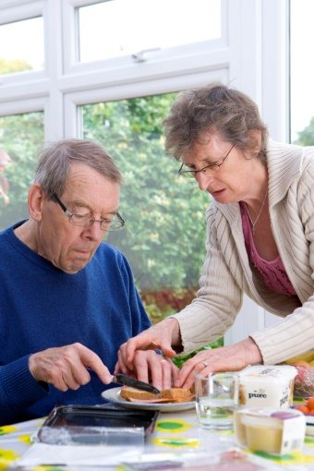
Practice looking for Carers to join its register

The practice has a duty to register and care for carers who are registered amongst the practice population. However, at Sherwood House the practice is currently unaware that many patients are caring for a family member.

As at May 2017, the practice is only aware of 187 patients who regard themselves as a Carer. This is a tiny fraction of the practice population of 13,000 patients – around 2%. We know from national figures that around 10% of the population have caring responsibilities and this rises to around 20% of 50-60 year olds.

What do you need to do to register?

Just tell your GP on your next visit or ask to join the Carer’s register at reception. This information will not be shared with anyone else.

However, it might help the practice to care for you better if it understood your caring responsibilities.

New System for Online Booking a Success!

The Patients group has been working with the practice to simplify the process of registration for online booking an appointment. The process has now been simplified which means it is easier for patients to register. Once registered, you can make an appointment with a doctor from the comfort of your own home, without having to wait at reception or on the telephone.

The practice are also looking to increase their online appointments (which are currently morning and afternoons) to offer some appointments after 6pm. This might make it easier for those patients who cannot get time away from work or who have caring responsibilities.

Register now! Ask at Reception

Travel Vaccination & Immunisation Service to Stay

Following representation from the patients group the practice have decided to reinstate their Travel Vaccination Service. Earlier this year the practice decided that it might be easier if the Travel Vaccination & Immunisation Service was discontinued. This is because a member of practice staff has to stay up to date with all the latest guidance on the many different types of vaccination required to travel to different countries.

Alternative arrangements which meant patients travelling into the city centre were about to be put in place. However, several members of the Patients Group, who travel regularly tried the alternative arrangements and found them confusing and inconvenient. Representations were made to the practice about the difficulty that this would cause to patients. The practice has agreed to re-instate the service.

Practice Changes
Dr Wongso has now left us and Dr Abu Amara leaves this week. A new trainee D. Patel has joined us recently and a further trainee Dr Goh will be starting shortly. A new registrar, Dr Bedi starts on the 2nd August.
Where to go Out of Hours
Some patients may be unsure where they can get help with an urgent health problem that is not an emergency, when the surgery is closed.

Walk in Centres – NHS Walk in Centres will treat minor illnesses without an appointment and are open 8am to 8pm. Nearest walk in centres are:

South Birmingham GP Walk in centre,
15 Katie Road, Selly Oak,
Birmingham, B29 6JG.
Telephone 0121 415 2095

Summerfield GP & Urgent Care Centre,
134 Heath Street,
Birmingham B18 7AL
0121 389 1100

Parsonage St GP Practice & Walk In Centre
Parsonage Street,
West Bromwich
B71 4DL
0121 612 3575

