Sherwood House Patients Participation Group Newsletter
Summer 2016

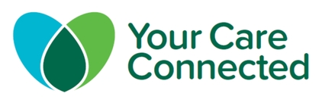
Your Medical History could save your life in an emergency
Sherwood House practice has agreed to take part in your Care Connected, a new NHS service being implemented across Birmingham, Sandwell and Solihull which will allow Doctors, Nurses and other registered healthcare professionals working in local hospitals to view information from your GP record, only with your permission, to provide you with better, safer care. You will already have received a letter from the practice telling you about this.
At the moment, when you go into hospital, access mental health or out of hours services, or need an ambulance particularly as an emergency, hospital staff caring for you do not have access to your record. GPs and the patients group at Sherwood House have debated the issue at our July Patients Group meeting and decided we think this needs to change, which is why we are supporting Your Care Connected.
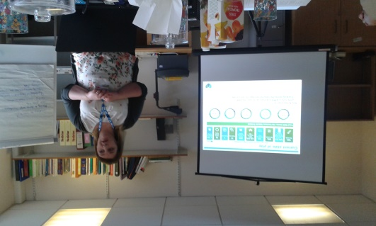

Sharing information to improve the care YOU receive
Your Care Connected will only be used to improve the care you receive when you visit one of the NHS organisations listed opposite. Your Care Connected

does not share your information with anyone other than the listed NHS organisations.
Your data will not be extracted, stored elsewhere, used for research or marketing or sold to any other organisations.
Who will be able to access your information?
- Birmingham Children’s Hospital
- Birmingham Community Healthcare
- Birmingham Women’s Hospital
- Birmingham City Hospital
- Birmingham and Solihull Mental Health Trust
- Good Hope Hospital
- Heartlands Hospital
- Queen Elizabeth Hospital
- The Royal Orthopaedic Hospital
- Sandwell General Hospital
- Solihull Hospital
- West Midlands Ambulance Service
- Local out of hours GP services
What will they see?
- Allergies
- Medication
- Hospital Admissions & referrals
- Test results
- End of Life wishes
- Medical procedures

What do I need to do next?
You do not need to do anything if you are happy to have those caring for you to see your information. If you do not want your information shared with those caring for you contact the practice.

Practice Rated “Good” by CQC
Following an inspection in September 2015, by the Care Quality Commission, the practice has now been informed that they are rated as “Good”. This rating is part of new regulations introduced under the Health & Social Care Act 2008 which requires each GP practice to be inspected every 3 years.
The full report is now available on the CQC website: http://www.cqc.org.uk/location/1-589733112

New Defibrillator for the Practice

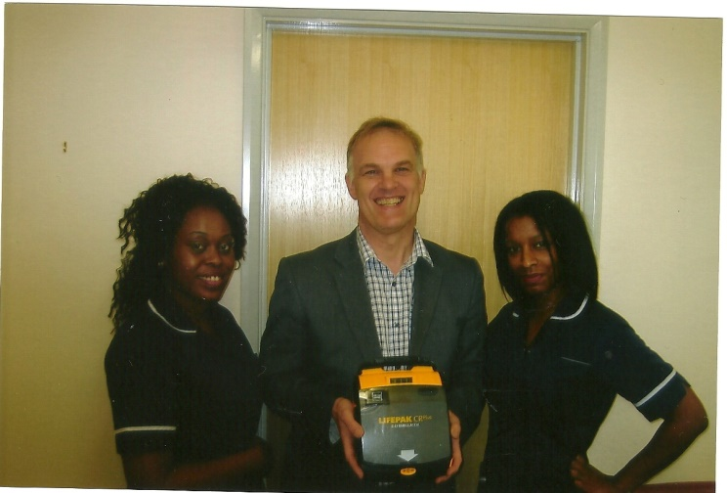

The practice has recently taken delivery of a new defibrillator donated by Jim Stevens from the Hearts of England Association (HOEA). They are a local run charity that supports specific projects identified by cardiology departments. They also support projects in schools, sports clubs and community clinics.
Dr Chew said “The defibrillator will only be used on rare occasions where there is an emergency, but it will allow us to carry out resuscitation in advance before the ambulance arrives.” A defibrillator is an electrical device that provides a shock to the heart when there is a life threatening arrhythmia present. Patients can be re-assured that the practice has a new defibrillator which can be used when needed.

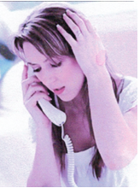

Online Booking is a hit with patients- More appointments added
The numbers of patients registered to use the online booking system at Sherwood House seems popular and has trebled in a year. The practice has recently added a number of afternoon appointments which can be made using the online booking system to cope with the demand. If you would like to register to use the system ask at reception for a registration form.

Practice changes Commissioning Group
Sherwood House has recently moved Commissioning Group to join Birmingham South Central Clinical Commissioning Group. Patients should not see any difference however the GPs felt that this move was needed because commissioning arrangements are slightly more relaxed in South Central CCG and practices are being encouraged to work together without forming new companies.

Birmingham South Central CCG values the views of patients and uses a number of different ways of capturing views such as:
- Snapshot focus groups
- Ideas Cafes
- Asking Patient Participation Groups to send in 2 questions per month on important issues

More details in the autumn issue of the Newsletter. If you have any ideas for topics we should cover put your ideas in the suggestion box at reception.

