Sherwood House Patients Participation Group Newsletter Autumn 2015

Practice Inspected by CQC
On Tuesday 22nd September 2015 Sherwood House Medical Practice had a comprehensive inspection by the Care Quality Commission. This visit is part of new regulations introduced as part of the Health & Social Care Act 2008 which requires each GP practice to be inspected every 3 years.
Four Inspectors (including a GP, a nurse and a patient representative from another area of the country) spent a total of 10 hours in the practice reviewing systems and processes, looking at records and policies. In addition they met with many of the clinical staff and spent over an hour and half talking to patient representatives from the patient participation group. Their patient representative also spent time in the waiting room talking to patients to find out their views directly.

What kind of issues are they looking at?
The Care Quality Commission has a duty to monitor Health and Social Care including GP services and they do this by collecting a variety of data and making
planned visits. They look at issues such as:
- Are services safe;
- Are services well led
- Are staff appropriately trained;
- Are clinical governance meetings held and learning practices acted on;
- Are the premises clean with good infection control systems and policies;
- Are staffing and recruitment systems robust
- Does the practice have good governance;
- Does the practice seek and act on feedback from patients, public and staff

When will we know the outcome of the visit?
A report on the Care Quality Commission’s judgement on the quality of care at the practice is expected in the next few weeks. We hope that it will be positive and that any recommendations will be constructive. We will feature the outcome in more detail in the next issue of the newsletter.

Practice changes
The practice has three new trainees: - Dr Shah, Dr Wongso and Dr Barimani. Dr Kay is due to retire in November after 30+ years. We wish him a healthy, happy retirement. Dr Kay says “I will be retiring with effect from 10 11 2015. This will be with mixed emotions as I have enjoyed and continue to enjoy working at Sherwood House striving to help patients in the best way that I can. I will miss meeting everyone. As many know I have had some significant health problems and recently have only been working part time. The time has now come to retire while I am still able to enjoy life spending more time with the family and horses. I will also have time to do other things I enjoy. Although in many ways I will be sad to leave Sherwood House I am looking forward to this new chapter in my life.”

Services to support Carers in Sandwell

Geoff Foster the Chief Executive of Sandwell Cares came to talk to the PPG on 21st September, 2015 to tell us about the range of services on offer to support carers who live in Sandwell. They provide;
- Telephone helpline for carers
- Outreach service for those housebound
- Advocacy services to help access services
- Carer’s Network to reduce isolation
- Adult Guidance and lifelong learning
- Carer get together and away days
- Culturally sensitive 1:1 support - Asian Carers
- Culturally sensitive 1:1 support – Afro Caribbean Carers
Their definition of a carer is “someone who without payment provides help and support to a partner, family member, friend or neighbour because they are ill, frail or have a disability” If you live in Sandwell, are a carer and need support contact Sandwell cares on
0121 558 7003

Email www.cares.sandwell@btinternet.com
Website: www.carers.org/sandwell
Practice Carers Register at the surgery
We want to encourage carers to make themselves known to the practice and join the carers register so the practice can help support you.
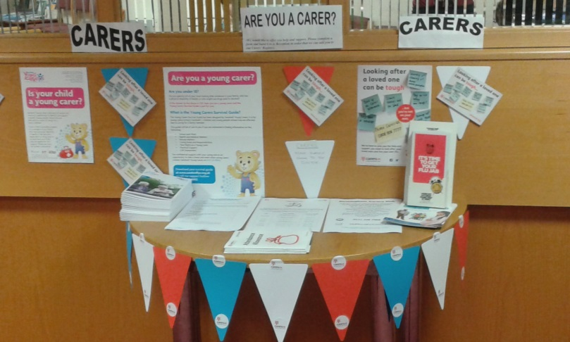

It is now recognised that carers, looking after someone else often neglect their own health or may need extra support at times. Joining the carers register at the practice lets the practice know you may have specific health needs associated with your caring activities and enable them to offer extra support where needed. On your next visit ask to join the carers register at reception.

Give us your Feedback
We would love to hear your views and suggestions on ways of improving services, although we cannot deal with individual complaints. Ask for a feedback form or drop a note addressed to the Chair of the PPG.

Facts & Figures for September 2015
- Doctors saw 2711 patients
• Nurses saw 361 patients
• 287 patients did not attend
• 94 appointments booked online
• 3277 prescription queries dealt with (direct issue, stored script, reprint or automatics)

New Models of Primary Care
The incredibly complex re-organisation of the NHS which began in 2013 is now beginning to effect general practice in a number of different ways.
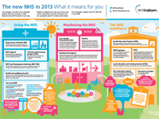
Practices are being encouraged to join together to form federations or Super Practices. The practice partners are currently considering which type of structure would best suit the practice for the future. They appreciate the need to work collaboratively with other practices locally but want to retain their autonomy. As the practice has 12,500 patients they think the practice is large enough to continue as a practice whilst working with other practices informally.

We will keep you updated on plans as these develop. As a patient group we want to keep a number of values that are important to us as patients, whatever models the government put forward. We want to maintain GP services which remain free at the point of need and which enable us to:
- get an urgent appointment
- See GP of our choice
- Be involved in planning our care/treatment
- speak in confidence to GP
- access hospital services when needed
- access hospital services based on clinical need rather than financial judgements
- access safe and effective out of hours care

