Practice coping with unprecedented demand for Urgent Appointments
Sherwood House Patients Participation Group Newsletter
Winter 2023

The practice is dealing with significantly higher numbers of patients seeking an urgent appointment, than last year. In addition, the practice is coping with many more patients who are on long waiting lists for hospital treatment and whose condition is becoming more complex. This is the main reason why patients are finding it difficult to get through on the phone.

The practice realise that patients are finding it difficult to get through on the phone and have increased call waiting capacity to 20 calls. This means that patients who call after 20, are being held in the system, will get a message saying calls are at capacity and to ring again. The practice is reviewing the telephone system and call waiting times with the patient group at every meeting.

At the same time some patients who book to see the doctor are not attending and not letting the practice know. This means appointments are being lost. Figures for the last 6 months show patients who booked an appointment for the doctor and then did not turn up. These are known as DNAs or Did Not Attends.

No of patients missing appointments in 2022

In total this means over five hundred appointments were lost. Please if you cannot attend your GP appointment, can you let the practice know so someone else could use that appointment

Having difficulty getting a blood test at the GP surgery?
If you are unable to arrange an appointment at the surgery please contact the Phlebotomy Booking Service. The best way to contact them is to email your request to swbh.phlebotomy@nhs.net
Mon to Fri 8-4pm
You will need your Name, Address, Contact number, Date of Birth and NHS Number. They offer blood tests at a number of centres. You will also need to take with you the blood form generated at the surgery. There is a telephone No but because of long waits email is best.
0121 507 6104

Wellbeing Walk from the Practice
Celebrates 5th Year Anniversary!

The Wednesday morning Ramblers Wellbeing Walking group is celebrating their 5th year anniversary with a walk!

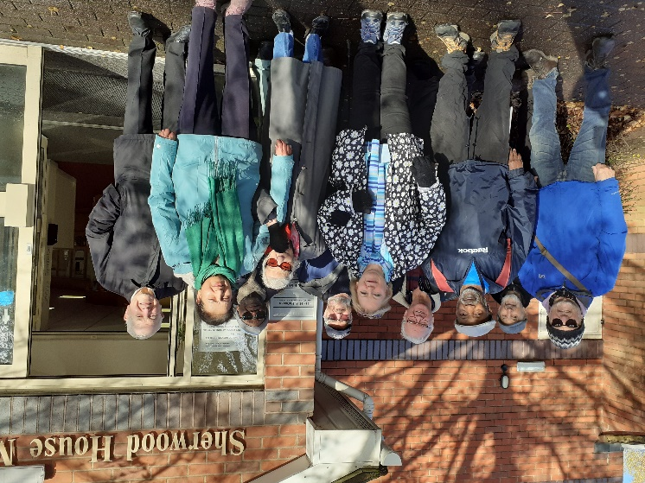

Started in 2019, the walk offers everyone access to a short group walk within easy reach of the practice and aims to help people become and stay active. The practice walk starts at 10am every Wednesday and anyone can join.

The walk from the practice is over easy terrain and the pace of walking can be adjusted to suit individuals. The walk is led by two trained walk leaders.

The group is very friendly, and welcoming. Members range in fitness level and age with at least two people on the practice walk being over 90! As well as improving fitness the walks help people stay socially connected and feel part of a wider group.

Evidence for Walking
Research has shown that being active reduces the risk of getting serious diseases, such as heart disease and strokes by between 20%- 50%. In addition to the physical benefits the walks improve self-esteem, mood and sleep quality by reducing stress and anxiety. Walking regularly can reduce the risk of becoming depressed by 30% and staying active helps those who are depressed recover.

The walk is recommended by the doctors at the practice. Dr Miller said “The walking group is an outstanding example of patient led health promotion. It provides positive health impacts from the physical exercise viewpoint and the mental health support side as well. We look forward to many more patients benefitting from this scheme." Why not give it a try?

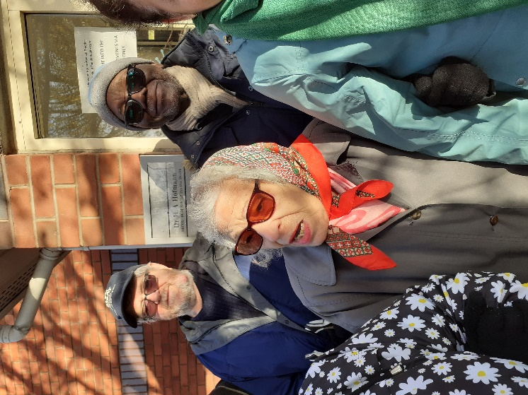
Lucy aged 89 pictured above before walking to Summerfield Park.

